EXPERIMENT NO - 3
AIM: Linux Process
TOOLS/SOFTWARES REQUIRED: Linux OS
THEORY:
In Linux, a process is an instance of a running program. The fork() system call is used to create a new process by duplicating the calling process. The newly created process is called the child process, while the original is the parent process. Both processes run concurrently and can be distinguished by the return value of fork().
Each process has a unique Process ID (PID), which can be obtained using getpid(), while the Parent Process ID (PPID) can be obtained using getppid(). Process synchronization is achieved using wait() and waitpid() system calls, which allow the parent process to wait for the termination of its child process and collect its exit status, preventing the creation of zombie processes.

OUTPUT:
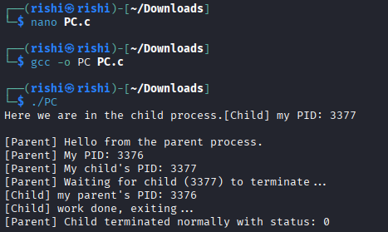
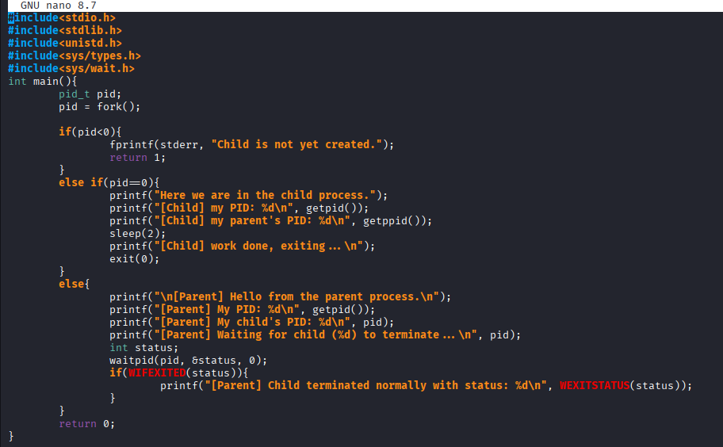

CONCLUSION: In this experiment, a child process was successfully created using the fork() system call. The process IDs of both the parent and child were obtained using getpid() and getppid(), helping to understand process hierarchy in Linux. The use of wait() and waitpid() demonstrated effective process synchronization by ensuring the parent process waits for the child to complete execution. This experiment provided practical insight into Linux process creation, identification, and termination handling.

